**ELEMENTS OF POWER SYSTEMS**

**EXPERIMENT 4**

**Codes:**

**1)**

clc

clear all

%Single phase 2 wire

V=input("enter the rms voltage in V: ");

L=input("enter length in m: ");

P1=input("enter power in VA: ");

pf=input("enter power factor: ");

N=input("enter the efficiency for system: ");

r=input("enter the resistivity in ohm m: ");

P=P1*pf;

loss= (100-N)*P/100;

Vm=sqrt(2)*V;

I=sqrt(2)*P/(pf*Vm);

a=r*L*I^2*2/loss;

Volume_required=2*a*L

%3 phase 3 wire

P=P1*pf;

loss= (100-N)*P/100;

Vm=sqrt(2)*V;

I=sqrt(2)*P/(pf*Vm*sqrt(3));

a=r*L*I^2*3/loss;

Volume_required=3*a*L

**Output:**

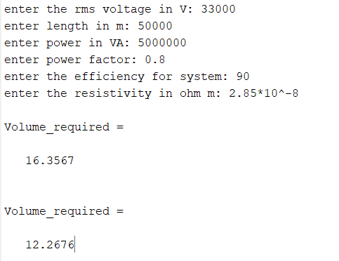

**2)**

clc

clear all

%Single phase 2 wire

V=input("enter the rms voltage in V: ");

L=input("enter length in m: ");

P=input("enter power in Watts: ");

pf=input("enter power factor: ");

N=input("enter the efficiency for system: ");

r=input("enter the resistivity in ohm cm: ");

specific_gravity=input("enter specific_gravity: ");

loss= (100-N)*P/100;

Vm=sqrt(2)*V;

I=sqrt(2)*P/(pf*Vm);

a=r*L*I^2*2/loss;

Volume_required1=2*a*L

weight1=Volume_required1*specific_gravity

%3 phase 3 wire

loss= (100-N)*P/100;

Vm=sqrt(2)*V;

I=sqrt(2)*P/(pf*Vm*sqrt(3));

a=r*L*I^2*3/loss;

Volume_required2=3*a*L

weight2=Volume_required2*specific_gravity

**Output:**

